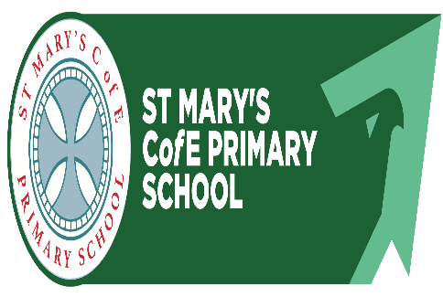

St Mary’s C of E
Primary School

SEN School
Information Plan
2025-26






Contents

Our School 03
Inclusion 03
Our Goals 03
What Are Special Educational Needs and Disabilities (SEND)? 04
Aims for Pupils with SEND 05
Involving Parents, Carers And Families 05
Pupil Participation 05
Provision for Pupils with SEND 06
Approach to Teaching 08
Professional Support within School 09
Supporting Pupils Transferring 11
Responding to Concerns and Worries 11
Our Autism Offer 12
Our Dyslexia Offer 13
Our Mental Health and Wellbeing Offer 14
Leicestershire’s Local Offer 15



Our School
This information is correct for the 2025/26 academic year:
- Children enrolled- 181
- Children with Special Educational Needs-37 (20.4%)
- Children with Education, Health & Care Plans or Top Up Funding-7 (3.8%)
- Pupil Premium Eligible Children- 36 (19.8)
- Looked After Children-4 (2.2%)
- Services Children- 2 (1.1%)
- Both SEN and Pupil Premium Eligible Children-9 (4.9%)
- EAL Children- 11 (6.0%)
- Whole School Attendance for the Previous Academic Year- 96.2%
- Fixed Term Exclusions from the Previous Academic Year-3 (1.6%)

Inclusion 
We are a Christian school and as a church school have a strong Christian ethos of care, empathy and understanding, aiming to ensure that each child is cared for holistically. We provide an environment where every child is valued and given the right support to help them reach their full potential. Each child’s ability, aptitudes, gifts, and talents are encouraged and we work together to develop these skills and provide the nurture and support all children (and their families) need whilst they are with us. The Head Teacher, staff and governors at St Mary’s C of E Primary School are fully committed to the integration and inclusion of every child. We do this in line with our school’s Christian Vision.

Our Goals
St Mary’s C of E Primary School have set the following goals:
- Our children will reach their full potential and will make ‘at least’ expected progress in line with their starting points
- Our children will have a positive sense of self image and worth, with high aspirations
- Our children will learn to be organised, confident and articulate.

We aim to achieve these goals through:
- High quality 1st teaching
- Skilled support
- Targeted intervention
- Listening to the views of our children
- Listening to the views of the parent/carer and having positive parent/carer relationships
- Involvement and support of external agencies when appropriate

What are Special Educational Needs and Disabilities (SEND)?
Special educational needs and disabilities (SEND) can affect a child or young person’s ability to learn. They can affect their behaviour or ability to socialise. They can affect academic learning, for example a child may have reading problems because they have dyslexia. They can affect their ability to understand things or their concentration levels, for example because they have ADHD. They may also affect their physical ability. The broad areas of special educational needs that we support at school are:

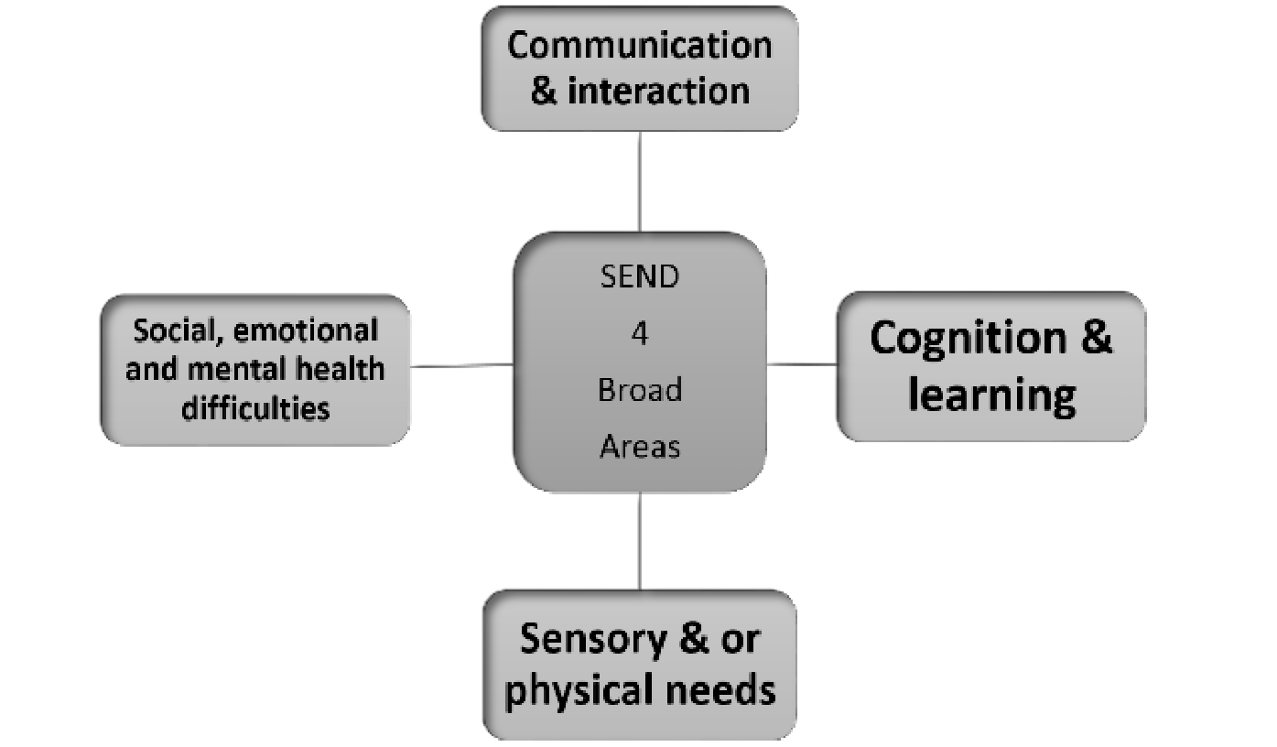

Aims for Pupils with SEND
Our aims for pupils with Special Educational Needs and Disabilities are the same as for all of our pupils; to provide a broad and balanced curriculum and the highest quality of education. We have high ambitions for our SEND pupils and set targets that stretch them. We are a very inclusive school and support pupils to ensure their integration and curriculum entitlement. We also value personal and social development and offer support for children and families who are experiencing this as a barrier to learning.
In order to achieve our goals, many steps are taken to support our children through their learning journey. High Quality Teaching is vital for all children and all children receive this; however, for some children there are occasions when further help or additional support may be needed. You know your child best and you may feel that your child needs some additional help or support so if you have concerns about the progress, attainment or social and emotional well-being of your child in the first instance speak to your child's class teacher and together you may then decide to involve the SENCO or Head Teacher to discuss your concerns further.

Involving Parents/Carers and Families
We are a friendly and approachable school with an aim to inform and involve parents as much as possible in school decision making and to provide them with support, advice, and access to services. Our view is that you are the expert on your child’s needs and for that reason we will encourage you to take the lead when setting short- and long-term outcomes.

Pupil Participation
We listen to our pupils and enable them to be active participants in their learning. We encourage them to evaluate themselves as learners and express opinions and make choices. All our SEND pupils have SEN Pupil Profiles that are produced in conjunction with the staff, pupils and families and enable them to identify their strengths and weaknesses, ways of learning best and what support they may need.
We have termly reviews with the children to gain views on their learning represented at those meetings.

Provision for Pupils with SEND
The SEND code of practice 2014 states that schools MUST use a ‘graduated approach’ to supporting children with Special Educational Needs and here at St Mary’s C of E Primary School we operate a phased approach to ensure that we are removing and reducing barriers to learning and ensuring that our SEN provision is of a very high quality.
We work with 6 clear phases to identify and provide a graduated framework. These phases are not automatically linear and, where necessary, children are started at the most appropriate phase or fast tracked through if we have evidence of their needs requiring it.

If a child is not making as much progress as we expect or has
a specific area that they are finding tricky, teachers will raise a concern to the SENCo. and the parents and monitor the child’s progress more closely. Parents too can raise a concern at parent’s evenings or by making an appointment with the class teacher in the first instance.
1
Phase Description
- If a child continues to struggle with progress or has a specific area that
continues to be difficult, class teachers will use all the information gathered and formulate a SEN Pupil Profile. These targets will be set according to their area of need and will be SMART (Specific, Measurable, Achievable, Realistic, Time scaled). The class teacher will monitor them regularly and discuss them with the SENCO termly. Parents will be part of the process with the review of the Pupil profile. Once all parties agree on targets set a new copy of the Pupil Profile will be formulated and sent out to parents.
- If the gap in progress isn’t narrowing, despite intervention, the SENCo. may do more detailed assessments and/ or refer to an external agency for further support and assessment.
- If Phase 3 is needed over an extended period of time and the gap is still widening a SEND Support Plan (SSP) will be written for them. The SENCo. may then, in consultation with parents, decide to apply to the Local Authority for Intervention Funding or an Education, Health and Care Plan (EHCP) to help support the child further.

- The government and Local Authority set out clear criteria that have to be met for an EHCP to be given. If the application is successful, it becomes a legally binding document with statutory obligations in it for schools and other agencies and enables a child’s education to be safeguarded and ranked of highest importance as well as strengthening child and family choices and views.
- As a school, we will always make reasonable adjustments to any part of our school day and environment to ensure all children are included. However, if we cannot not fully meet the needs of a child, we would support the family in accessing a specialist placement for their child. A child MUST have an EHCP to be considered for a specialist school.

Within each phase and termly, a 4-part cycle occurs:

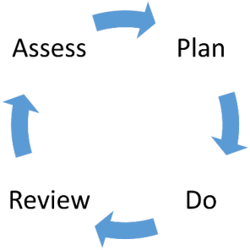

Assess
Assessments are conducted at regular intervals which are used to inform the next steps. Class teachers have termly meetings with the SENCo and then these are shared with parents enabling a full analysis of the child’s needs to be gathered.

Plan
The information gathered is used by the class teacher to produce bespoke targets and necessary provision which is then recorded on the child’s SEN Pupil Profile. If specialist equipment or facilities are required, then we consult with the Specialist agencies to ensure that

the classroom environment is suitable for pupils with specific learning needs and that they can access the right equipment e.g., visual and hearing impairments.

Do
The plan is implemented with the class teacher being responsible for the monitoring and assessment of the provision provided.

Review
The effectiveness of the support and interventions and their impact on the pupils’ progress are reviewed termly. The impact and the quality of the interventions along with the views of the pupils and their parents are evaluated and so the cycle begins again.

Approach to Teaching
We are a supportive and nurturing school with a very dedicated staff team, all of whom view themselves as teachers of all pupils with SEND. Our staff are always developing their skills to ensure quality provision for pupils with a range of learning needs and all staff are given training in a broad understanding of specific difficulties.
Our overall aim is to provide the highest quality of teaching for all pupils. We are inclusive and understand the need for adjustments and additional support in class for some pupils. The team of professionals who work alongside the class teachers are:

Special Educational Needs Coordinator (SENCo.)
The SENCo. is a qualified and experienced teacher. She is also part of our SLT (Senior Leadership Team). She has `global' responsibility for staff knowledge and understanding and must ensure they remain up to date with current issues and should gain support and information from the local SENCo. network. Much of our SEN CPD needs can therefore be addressed in-house through the work of the SENCo.

Mrs. Laura Oakes,
St Mary’s C of E Primary School
Brampton Road
Melton Mowbray
Leicestershire
LE130NA
Tel: 01664 562500
Email: loakes@stmarys.risemat.co.uk

Support Staff
Where extra support is required, we have trained highly skilled Teaching Assistants whose work is directed by the class teacher or SENCo and based on targets outlined on the SEN Pupil Profile.

Head Teacher/SEN Governor:
For advice on additional concerns contact our Head of School Mrs. Laura Oakes
or our Assistant Head Teacher Mr. Paul Galvin in the first instance or email our SEN Governor Dr Julia Pointon at jpointon.gov@stmarys.risemat.co.uk or email the school office at office@st-maryscofe.leics.sch.uk. If it is a matter of urgency then please call the school on 01664 562500.

School

Educational Psychologist
We have allocated Educational Psychologists employed by the Trust. Schools individually request children are taken to panels and they will decide if psychologist involvement is needed.
To help understand the pupils' educational needs better, the psychologists will request information from both parents and the school. They use this information to inform their assessments and then provide a written report after their visit. They will give feedback to the school and will provide telephone feedback for parents if requested. The psychologists will offer advice to the school and the parents/carers on how best to support the pupil in order to take their learning forward. The school consults with the Trust if there is any doubt about whether a formal assessment is necessary.

School Nurse Services
The School Nurse team can be contacted on:
School Nurse Team,
The Children’s Community House,
Melton Mowbray Hospital,
Thorpe Road,
Melton Mowbray,
LE13 1SH
Tel: 01664 855561

SENA Special Educational Needs Assessment:
Leicestershire County Council, County Hall,
Leicester Road, Glenfield, Leics,
LE3 8RA
Tel: 0116 3056600

Speech & Language Therapists:
Bridge Park Plaza, Bridge Park Road, Thurmaston, Leics,
LE4 8PQ
Tel: 0116 2955256

Hearing & Vision Support Service

Leicestershire County Council, County Hall,
Leicester Road, Glenfield, Leics,
LE3 8RA
Tel: 0116 3059400
Email: STS@leics.gov.uk

Autism learning Support Service
  - Area Outreach Advisory Teacher: Lindsay McCalla
  - Behaviour Support Services: Oakfield School Support
  - Outreach Teacher: Zoe McNeil

Supporting Pupils Transferring
We understand that transitions can be particularly difficult for pupils with special educational needs and we collaborate closely with other schools and agencies to ensure as smooth a process as possible. We can arrange additional support for their high school transfers such as extra visits. If your child is moving to a new primary school or coming from another primary school then we will always endeavor to talk to the relevant staff in person and ensure all support needs are in place.
We have close links with our feeder pre-schools and our local high schools. Children with EHCP plans will have transfer review meetings for high school and nursery.

Responding to Concerns and Worries
We are a very approachable school and all of our staff are easily available. You can chat to your child’s teacher at the end of the day or arrange appointments through the school office or email a member of staff through the office if you prefer.

We will ensure an appointment is made with the SENCo or relevant members of the Senior Leadership team as soon as possible where actions can be agreed together and a time to review how it is going can be made.
If you have an issue that you don’t feel can been resolved in school, you can also approach our governing body. Our SEND governor, Dr Julia Pointon, would be happy to help.
If there are needs you don’t feel are being addressed by the school then SENDIASS offer free, impartial, confidential information and support:
SEND Information Advise Service Leicestershire County Council, Bassett Street,
South Wigston, Leics,
LE18 4PE
Tel: 0116 3055614
Email: sendiass@leics.gov.uk

Our Autism Offer

Autism is a lifelong, developmental disorder that affects how a person communicates with and relates to other people. It can also affect how they experience the world around them. Autism is a spectrum condition meaning that it affects people in different ways, 66% of people born with Autism do not have additional learning difficulties.
- (Tier 1)- Our classrooms are autism aware. Our staff have had training in autism awareness. We also understand the need to provide classroom adjustments for some pupils.

  - We use visual timetables and additional visual menus to support pupils and provide clear routines and structures.
  - We offer parents support at identification stage and clear pathways to help them investigate a diagnosis, including access to our Educational psychologist if autism is widely suspected. We communicate effectively with Pediatricians and will attend MDT meetings where professionals have identified the need to investigate autism.
  - We work closely with the Autism Outreach Service; our key link adviser is Lindsay McCalla. We access training and support from the service when a specific need is identified. We encourage and promote diversity and understanding of autism.

Our Dyslexia Offer

Dyslexia is a learning difference that affects about 10% of the population, some more severely than others. It affects the skills needed to learn to read with fluency, accuracy, and spell accurately. We offer a wide range of dyslexia friendly strategies and tools to support pupils with dyslexia:
  - Dyslexia friendly classrooms with additional access to adjusted reading materials for pupils with identified needs. Our staff have been trained in dyslexia aware teaching practices, including multi-sensory learning.
  - Dyslexia aware guidelines with a clear structure of support.
  - Clear pathway to identification of dyslexic difficulties, which includes monitoring those children at risk from the foundation stage.

Our Mental Health and Wellbeing Offer

We recognise the importance of good mental health and promoting wellbeing in a positive way. We also understand that mental health problems are a growing concern for schools. We have a nurturing school ethos, a strong set of school values, a PSHE curriculum that addresses mental health and a clear anti- bullying policy. We develop behaviour plans for children who need help with social skills, resilience, and emotional regulation. We have invested in staff training for mental health and wellbeing groups and our Educational Psychologist supports children and families with significant need.
We use Oakfield Outreach support for training in de-escalation and support needs. We work closely with Social Services and Wellbeing Practitioners.

Professional Support for Parents
This can also be accessed from the providers below:
  - Support for Mental Health- Early Intervention Service Tel: 0116 254 3011
  - Gingerbread- Support and Advice for Single Parents. Tel: 0800 018 4318
  - ADHD Solutions- Support to Families affected by ADHD Tel: 0116 2610711 or Email: www.adhdsolutions.org.uk
  - Young Minds Parents Information Service- Advice to parents on concerns relating to their children’s mental health.
Tel: 0800 0182138 or Website: https://youngminds.org.uk/
  - The Laura Centre- Bereavement Support Website: http://www.thelauracentre.org.uk
  - Cruse Bereavement Service
Tel: 0116 2544341 or Website: https://cruse.org.uk

Young Carers Service
This can be accessed from the providers below:

  - Barnardos Carefree- Support for Young Carers (up to age 19) who provide regular care for family members
Tel: 0116 2867182 or Website: http://www.barnardos.org.uk/carefree
  - Counselling for young people is available online, free of charge in Leicestershire via www.kooth.com

Leicestershire's Local Offer:
The Leicestershire Local Offer gives children and young people with special educational needs or disabilities (SEND) and their families information about help and services in Leicestershire.
There is an opportunity for you to tell the Local Authority what you think of the Leicestershire Local Offer and your experience of services and facilities for children and young people with special educational needs and disabilities (SEND).
You can also find feedback about the Leicestershire Local Offer from parents and people who care for and work with children with special educational needs and disabilities (SEND). Also find out what the Local Authority has done in response.
https://www.leicestershire.gov.uk/education-and-children/special- educational-needs-and-disability

